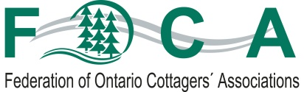
YOUR ROLE: Write to the Minister in support of the Lake Partner Program
November 2018

At the FOCA Fall Seminar on October 27th, Board President Marlin Horst issued a call-to-action to all FOCA members.
Here is an overview of his words:

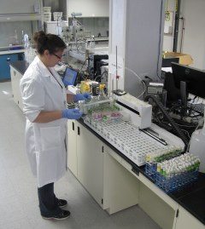
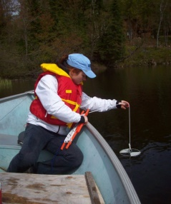
The Lake Partner Program (LPP) partnership between FOCA and the Ministry of the Environment (now Ministry of the Environment, Conservation, and Parks - MECP) supports the hundreds of volunteers who diligently sample Ontario’s inland lakes and measure water clarity each year, as well as a dedicated position at the Dorset Environmental Science Centre (DESC), to coordinate and administer water sampling kits and the sample analysis by DESC scientists.
This important long-term data collection, management, and interpretation would not be possible without the ongoing efforts of the MECP, FOCA’s staff, and LPP volunteers. Find out more, here: https://foca.on.ca/lake-partner-program-overview/.
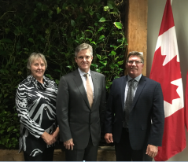
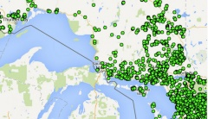
The Province has made stern warnings about their fiscal situation, and—in the Ernst & Young report (Sept. 21, 2018) and elsewhere—have referenced the need to rationalize or modify their approach to Transfer Payments to partners and service delivery agents. While the majority of such funding is tied to health care and education, any wholesale change to third-party funding/program support may affect small-but-important agreements such as the one between FOCA and MECP for the LPP. FOCA recently met with MECP Minister Rod Phillips and his senior staff, to make them aware of the importance of the work we do together. We value the effort our volunteers put into this program, and the science that it produces – science that otherwise would not exist.
If you feel strongly about the continued role of DESC and our lake partner volunteers, we encourage you to write to your home MPP, your cottage country MPP, and the Minister himself on behalf of your members, to tell them how important water quality monitoring is to your community, and how the Province can continue to capitalize on this very cost-effective program by continuing their modest support of the Lake Partner Program through FOCA.
Please copy president@foca.on.ca on your letters! (see words, over…)
DRAFT for FOCA member use:

November __, 2018

To: Hon. Rod Phillips
Ontario Minister of the Environment, Conservation & Parks
rod.phillips@pc.ola.org

cc: president@foca.on.ca

[also, your MPP and cottage country MPP]

Honorable Minister Phillips:

FOCA is the Federation of Ontario Cottagers’ Associations. As one of FOCA’s 50,000 member families, and on behalf of my own lake Association, __________ in ________ Township, I am writing in support of the Lake Partner Program (LPP), a long-term partnership between FOCA, the Ontario Ministry of the Environment, and the Dorset Environmental Science Centre.

The LPP program has significant value:
- it is one of the largest of its kind in the world, using volunteers to sample water quality in Ontario’s inland lakes
- 1,000’s of hours of volunteer water sampling each year, by hundreds of citizens
- data dating back to 2002, tracking water quality across Ontario.
For more, visit: https://foca.on.ca/lake-partner-program-overview/.

The Province of Ontario can continue to capitalize on this very cost-effective program by continuing its modest support of the Lake Partner Program through FOCA. On behalf of my family, my lake Association and FOCA, I urge you to continue supporting the Lake Partner Program of water quality monitoring.

Sincerely,

[your contact information & lake association affiliation here]

