FOCA Aquatic Invasive Species Prevention & Monitoring Program
Tips for Boaters
Some aquatic species can survive more than two weeks out of water

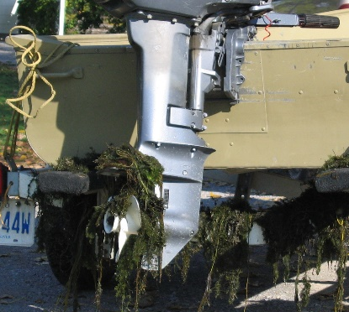
Before you go
1
Visually inspect your boat, motor, trailer and all fishing gear. Look for aquatic debris that might be dried and still clinging to your equipment since the last outing. Washing and/or drying your equipment will kill harmful invasive species.

Watch out
2
While on the water, steer your boat or watercraft clear of areas known to have invasive species. Propellers can cut up plants; and oars or paddles can break stems, further spreading invasive species.
Eurasian Water-milfoil on boat motor and trailer.

When you leave
3
At the boat launch, inspect your boating equipment: boat, motor, trailer, rollers, axles, anchors, centerboards and fishing gear and remove any zebra mussels and/or other animals and plant debris (stems/leaves) that are visible. Dispose of debris in the garbage, or compost on land - never near any waterbody. Prior to leaving the boat launch, drain water from the motor, live well, bilge, and transom wells, and leave your drain plug out while travelling.

Follow these Quick Tips:
GOOD | BETTER | BEST
Clean, Drain | Clean, Drain, Dry | Clean, Drain, Disinfect
- CLEAN off all visible mud, vegetation and other debris  - Pull and store the DRAIN plug, lower your outboard to drain standing water and drain live wells before leaving the launch | - In addition to cleaning and draining:  - DRY your boat and equipment in hot or sunny weather for 2-7 days before transporting them to another body of water | - Use a pressure washer to spray off your boat and trailer (250psi) OR rinse off your boat and trailer with hot water (greater than 50°C)  - To prevent the spread of VHS, rinse live wells with 10% household bleach/water solution (i.e. 100ml of bleach to 1L water). Rinse well with water to remove any residual chlorine.

Found a suspected invasive species? Report it:
1-800-563-7711 or http://www.eddmaps.org/ontario/

