Northern Ontario Internet
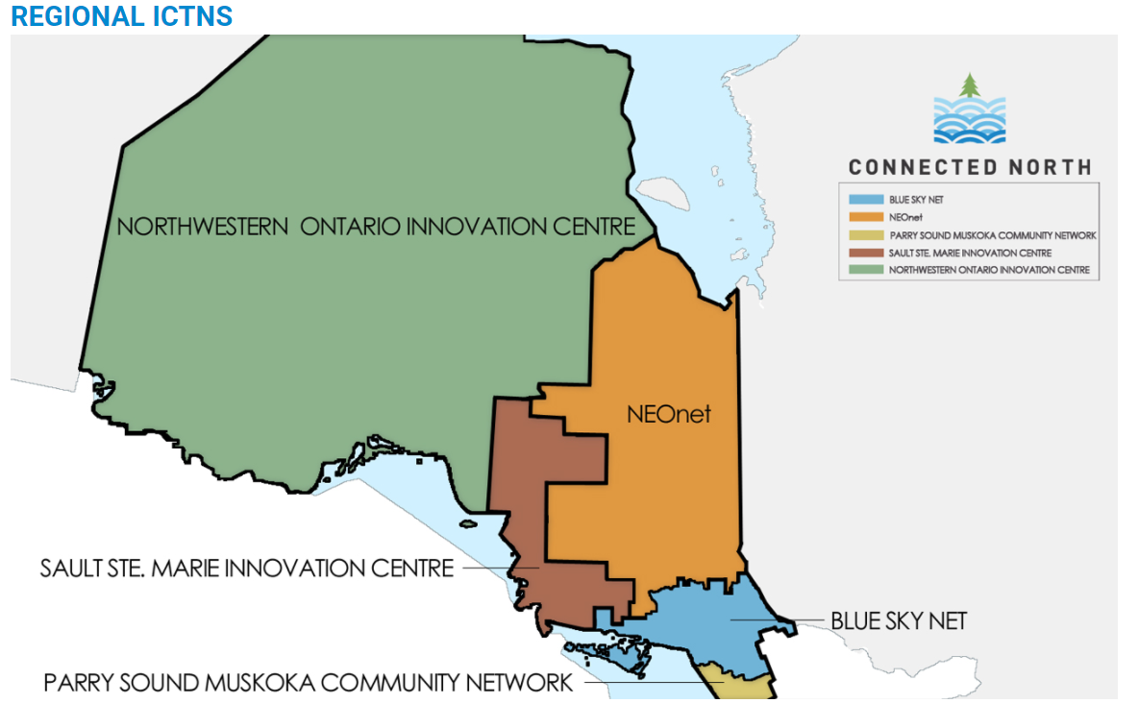
“The Speed of Northern Ontario Broadband.” http://www.connectednorth.ca
FedNor provides funding for the operation of the non-profit technology development networks in Northern Ontario. Each ICTN works within a set service delivery area . To contact your ICTN looking for specific information about your area, see the contact info below. If your questions or comments are not specific to an area, please use the contact information for general inquiries.

BLUE SKY NET
102-150 First Avenue West
North Bay, ON P1B 3B9
T : 705-476-0874
W : www.blueskynet.ca
E : info@blueskynet.ca

PARRY SOUND MUSKOKA COMMUNITY NETWORK
100 Muskoka Road South, Unit D – P.O. Box 524
Gravenhurst, ON P1P 1T8
T : 705-646-9044
W : www.pmcn.ca
E : info@pmcn.ca

NEONET
4715 Highway 101 East
Suite B-142
Northern College – Timmins Campus
South Porcupine, ON P0N 1H0
T : 705-360-1353
W : www.neonet.on.ca
E : info@neonet.on.ca

SAULT STE. MARIE INNOVATION CENTRE
99 Foster Drive. Level Six
Sault Ste. Marie, ON P6A 5X6
T : 705-942-7927
W : www.ssmic.com
E : info@ssmic.com

NORTHWESTERN ONTARIO INNOVATION CENTRE
Suite 603
34 Cumberland St. North
Thunder Bay, ON P7C 5K4
T : 807-768-6682
TF : 1-866-768-6682
W : www.nwoinnovation.ca
E : info@nwoinnovation.ca

