May 8, 2023
Floating Container Homes: Briefing for Municipalities
The Problem:
Lakes and rivers in Ontario are facing a new threat: unregulated float homes.
Municipalities, property associations and thousands of individual residents are deeply concerned by the potential environmental, social, economic, and public safety impact(s) these structures can cause to our waterways, if left unregulated.

The Ontario Government has recently consulted Ontarians on this matter and appears willing to bring these floating homes under regulation. But its hands are tied.

The problem is that in Ontario, Transport Canada classifies such structures as “vessels”, while in British Columbia, Transport Canada classifies them as “float homes”. There is, accordingly, a lack of national consistency in Transport Canada’s oversight of these structures.

As a result, in Ontario, as a "vessel", these structures are currently exempt from all forms of oversight and regulation, including building code adherence, environmental protection, navigation and public safety, taxation and location management.

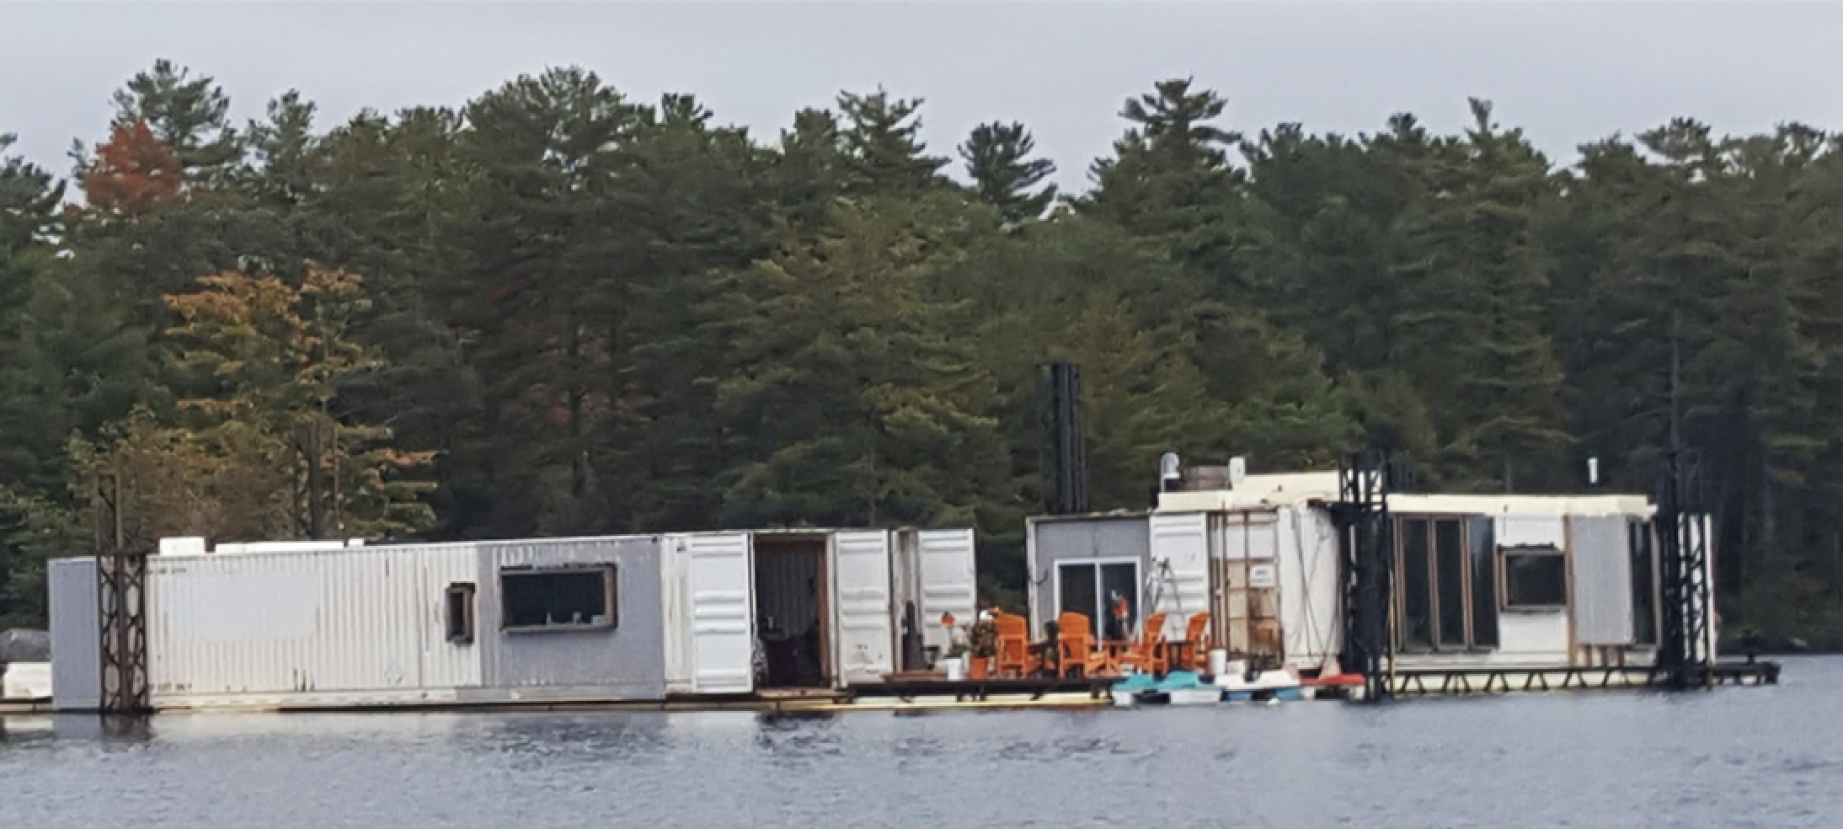
These structures are used exclusively for residential purposes and are NOT primarily intended for or even usable in navigation. There are multiple versions: they may consist simply of shipping containers welded together and floating on Styrofoam; some are stabilized to the lakebed by steel stakes to elevate above mean water level and remain completely stationary with docks affixed to them, while others are two storey residential structures. None of these float homes, however, behave as a vessel and as such they should not be classified as “vessels”.

But in British Columbia, where Transport Canada classifies them as “float homes”, these structures must conform to strict building standards and can be duly regulated by the province and municipalities to ensure environmental protection and location management.

What Do We Want to See?
- Floating structures which are primarily intended for residential use, to be classified as “float homes” as defined under Transport Canada’s “Standards for Float Homes and Live-Aboard Vessels in Victoria Harbour”
- Any of these structures in Ontario currently classified as “vessels” to be re-classified as float homes.
What Are We Doing?
To protect Ontario’s waterways on this issue, thousands of individual cottagers and waterfront residents, multiple cottage associations, as well as numerous municipalities and other stakeholders, are making their concerns known.

Specifically, we are writing to the federal Minister of Transport, submitting a Petition to the House of Commons, engaging individual Members of Parliament, and working with cottage associations.

Municipalities, too, have a critical role to play.

These are not “vessels”. We urgently need your help!
What Can Your Municipality Do to Help?
As a Municipality with a significant population of waterfront residents and cottagers, you can take steps to urge the federal Minister of Transport to de-classify these structures as “vessels”.
An important step would be to pass a Municipal Resolution in favour of the re-classification of these structures as float homes. This step has already been taken by several Ontario municipalities, including the Township of Georgian Bay and the Township of Lake of Bays.
For example, the Lake of Bays passed the following resolution in April of 2022.
chrome-extension://efaidnbmnnnibpcajpcglclefindmkaj/https://tecumseh-pub.escribemeetings.com/filestream.ashx?DocumentId=31557
This Resolution was shared with the Association of Municipalities of Ontario.
Once these structures have been re-classified as “float homes”, Municipalities may proceed to enact and enforce by-laws pertaining to them. This authority to act was confirmed in the case of Glaspell v. Ontario (2015), which concluded that “a municipality is empowered to enact by-laws that regulate the use of land in the municipality including land in the municipality covered by water…and regulate the type of construction and the height, bulk, location, size, floor area, spacing, character and use of buildings or structures to be erected or located within the Township..”.
The Township of Georgian Bay has been a leading advocate for this reclassification, and in fact their council passed the appropriate By-Laws (3.2 and 4.6) so that they can effectively manage float homes once they have been reclassified from vessels to float homes.
Mayor Peter Koetsier of Georgian Bay Township has extended an invitation to all the municipal leaders we are reaching out to. He would be willing to speak personally to the Township of Georgian Bay’s journey in creating these two By-Laws and the Township’s expectations of how they’ll be effective tools in managing float homes once they have been classified as float homes.
As President of Gloucester Pool Cottagers’ Association and Founder of Float Homes not Vessels, I am keen to ensure that you have a complete picture of the issues, risks of not doing anything and benefits of the solution path we are pursuing.

Most Sincerely,

Cheryl Elliot-Fraser
President
Gloucester Pool Cottagers’ Association (GPCA)
president.gpca@gmail.com
Founder of Float Homes not Vessel

“Standards for Float Homes and Live-Aboard Vessels in Victoria Harbour”, Transport Canada, November 2001

