To: | Cc:
The Honourable Omar Alghabra  Minister of Transport  Ottawa  TC.MinisterofTransport-MinistredesTransports.TC@tc.gc.ca | Arun Thangaraj  Deputy Minister  arun.thangaraj@tc.gc.ca
Joanna Manger
Director General Marine Safety & Security
joanna.manger@tc.gc.ca

I am writing to you regarding the subject of unregulated float homes in Ontario.
Municipalities, property associations and thousands of individual residents are deeply concerned by the potential damage including environmental, social, economic and public safety impact(s) these structures can cause to our waterways, if left unregulated.
The Ontario Government has recently consulted Ontarians on this matter and appears willing to bring these floating homes under regulation. But its hands are tied, they need your support to enact changes per the recommendation set out below.
The problem is that in Ontario, Transport Canada classifies such structures as “vessels”, while in British Columbia, Transport Canada classifies them as “float homes”. There is, accordingly, a lack of national consistency in Transport Canada’s oversight of these structures.
As a result, in Ontario, as a "vessel", these structures are currently exempt from all forms of oversight and regulation, including building code adherence, environmental protection, navigation and public safety, taxation and location management.
These structures - often consisting simply of shipping containers welded together and floating on Styrofoam - are used exclusively for residential purposes and are NOT primarily intended for, or even usable in navigation. To be even clearer, there are multiple versions (shown in pictures next page); some are stabilized to the lakebed by steel stakes to elevate above mean water level and remain completely stationary with docks affixed to them, others are two storey residential structures. Neither of these example floating homes behaves as a vessel and as such they should not be classified as “vessels”.
In British Columbia, where Transport Canada classifies them as “float homes”, these structures must conform to strict building standards and can be duly regulated by the province and municipalities to ensure environmental protection and location management. The result is a thriving, but regulated, community of over 500 float homes in the province.
Accordingly, I respectfully request that your Department classify float homes in a manner consistent with the precedent it established in British Columbia in 2001.
More specifically, here is a summary of how Transport Canada, in collaboration with the Government of British Columbia and local government, created the outcome which we also desire to see in Ontario:
- This policy development started with the British Columbia Float Home Standard of 1998, under the Ministry of Municipal Affairs. This standard was created to control location of mooring and to control building standards.
- Subsequently, in November 2001, Transport Canada published the “Standards for Float Homes and Live-Aboard Vessels in Victoria Harbour”, to reflect the jurisdiction and specific requirements of Transport Canada for Victoria Harbour. That document defined a “float home” as “…a structure incorporating a flotation system, intended for use or being used or occupied for residential purposes…not primarily intended for or usable in navigation…”.
- This combination of federal and provincial standards classifying and governing Float Homes then allowed local governments throughout British Columbia to enact municipal regulations governing float homes in their jurisdiction, including over the location of mooring and the control of building standards.
A solution to this issue would help to protect the Ontario marine environment, safety and navigation - which are all strategic priorities of Transport Canada. The Ontario solution begins with Transport Canada classifying these floating residences in Ontario as “float homes” and not “vessels”, as you have already done this in British Columbia.
Once this change has been made, municipalities will be enabled to create bylaws to control float homes in a manner consistent with provincial and municipal standards. Already, the provincial Government and numerous municipal councils in the province are prepared to pass bylaws to control and regulate these structures.
Without this important first step led by Transport Canada, the province and municipalities cannot manage the location, use, taxation and safety standards of float homes while, at the same time, the important issues of protecting our marine environment, public safety and navigation are jeopardized.
I respectfully request your immediate attention and resolution to this matter.
Most Sincerely,
An Ontario Concerned Citizen

Illustrations
- Figure 1 – Three shipping containers welded together, stabilized with steel poles on lakebed on styrofoam flotation with full dockage
- Figure 2 – Next generation 2 storey floating homes currently in production and very similar if not identical to floating home structures that exist in British Columbia today
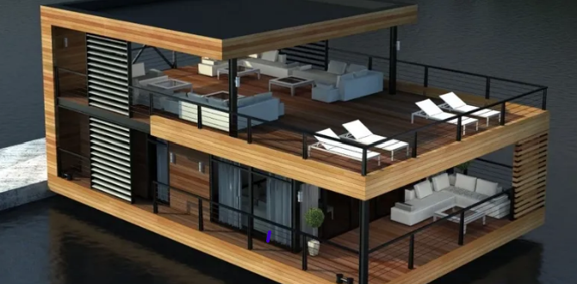
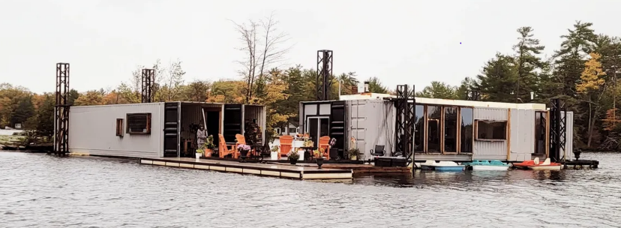
Figure 1 Figure 2

